**Data Structures Lab 1**

Vivek Kunapareddy(M08644070)

1. The concepts explored in the assignment were:
   1. Installing and setting up an IDE: This concept is extremely important when moving into the workforce as a software engineer would require extensive use of an IDE so ease and familiarity with one would help in transitioning into that position
   2. Modifying existing code: This concept is also of use to us as most of the projects we will work on are going to be existing codebases rather than files built from scratch. Hence being able to read and understand code written by someone else helps in transitioning into the workforce
   3. Struct design: The initial concept of data structures was also explored in this assignment as basic struct design. This gives us strong fundamentals for further improving upon data structures

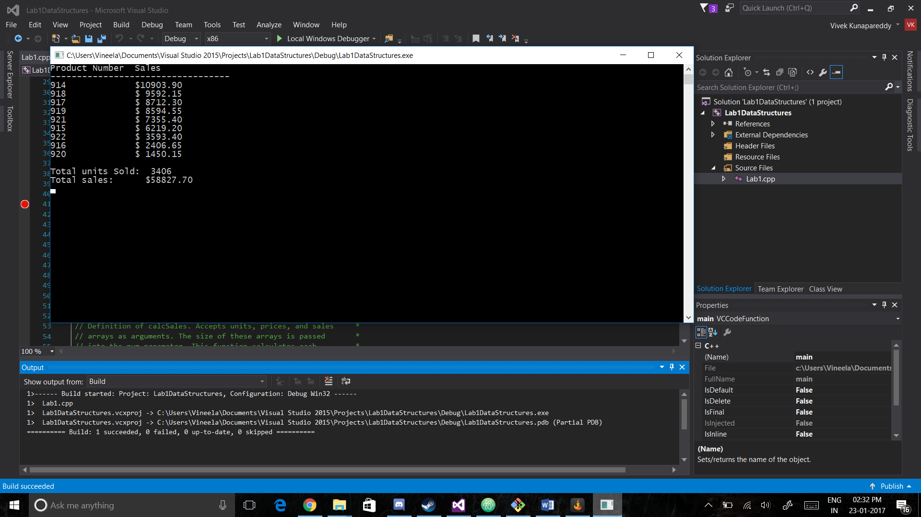

1. The debugging in task 2 was approached by firstly reading through the code and trying to understand what operations might have gone wrong. Then in order to see if the assumptions were right the code was compiled and the output was compared to the expected output. Upon finding them different the problem was fixed and the entire process was repeated until there were no more bugs.

The bugs fixed were pretty simple. Most of the fixes were slight error such as replacing div with qtr or forgetting to add the sales to the total sales. Finally the last problem was not initialising the int value to 0. Such problems can be avoided by compiling the code and checking if the output is as expected and if not it can be fixed.

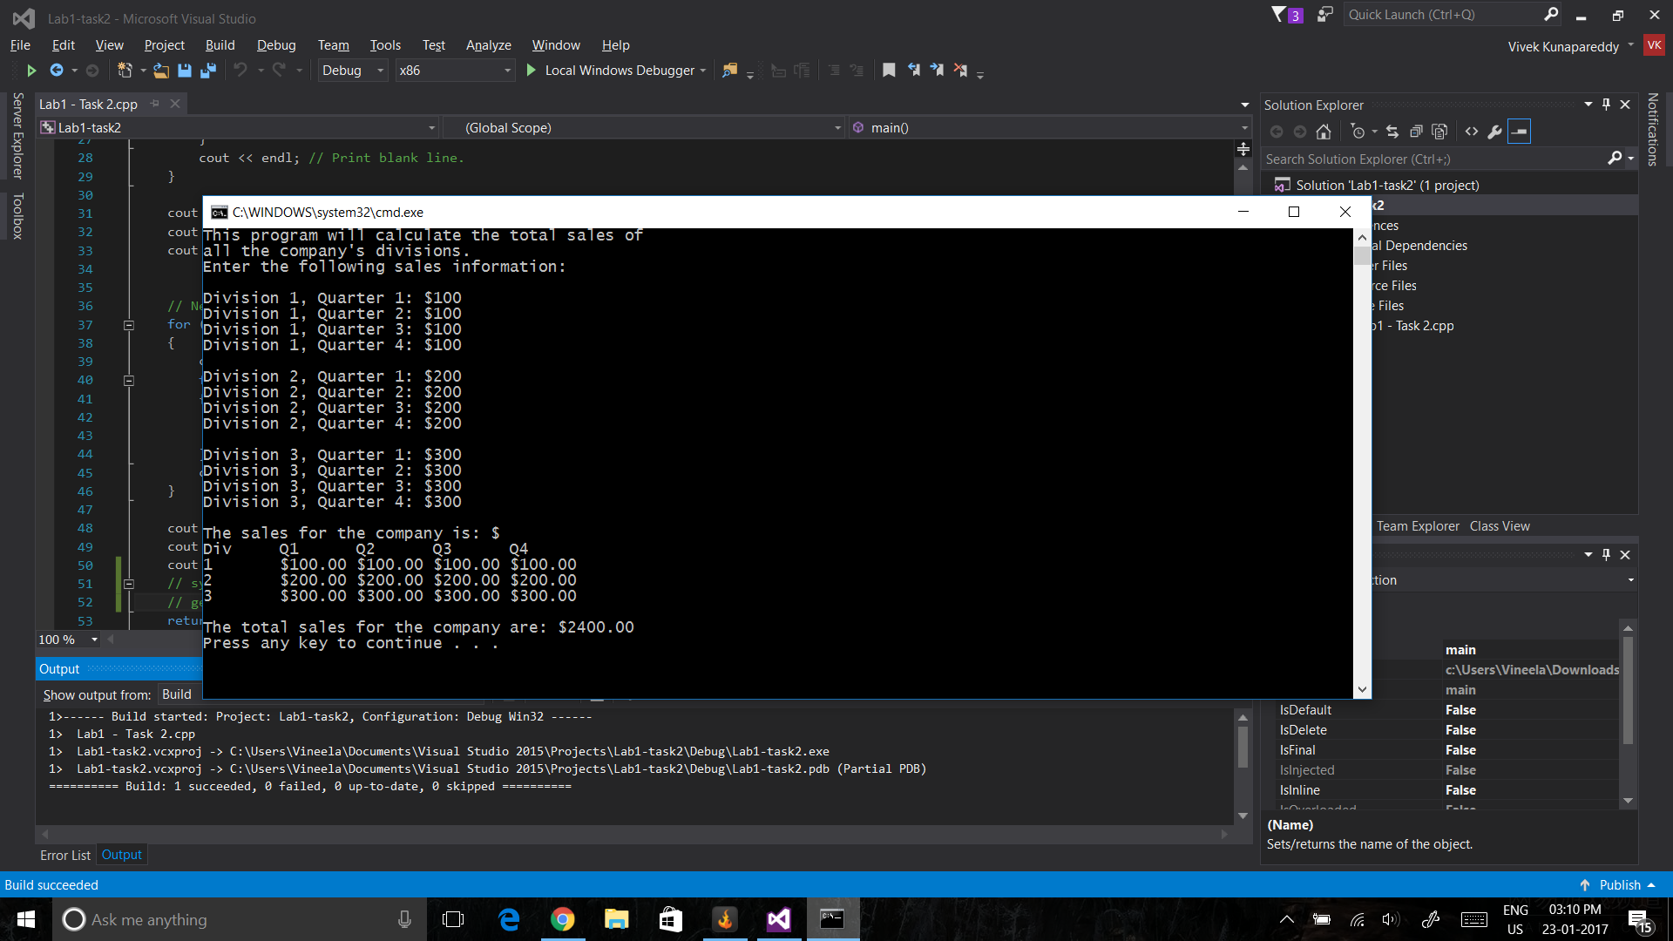

1. In task 3 we had to introduce a struct which could replace the 4 arrays we had been using in task 1. This was pretty simple as we could just create a struct which holds 4 integer values and then create an array of these structs. The bugs introduced were that the functions used to modify the 4 arrays were now looking for non existent arrays instead of the array of structs introduced. So in order to get rid of those the functions were modified to use the struct we had introduced